|  |
| --- |
|  |
| Opioid Crisis  Data Analysis  **ETL Group Project: Drew, Charles, Hayden**  October 2019 |

Finding data, cleaning data, organizing data, establishing a data base with the proper structure, and being able to analyze data is extremely important in the modern world. Data is prevalent and in order to be able to drive meaningful results and solutions, data analysis can play a pivotal part.

This document will cover:

1. Executive Summary
2. Sources of Data
3. Data Dictionary
4. Graphs that lead to cleaning
5. ERD diagram of our database
6. Our Table Schema
7. Five Queries Showing Analysis

# EXECUTIVE SUMMARY

**Opioids** are a major issue within the US. It is a leading cause of deaths. In order to understand this problem in more detail, we analyzed deaths in the US due to opioids from the CDC, where these deaths are occurring, who is prescribing opioids all in order to see if there are patterns that may lead to explanations of why this is occurring. The is a bold task, as there may be many environmental, social economic, and other factors that may be involved that were not taken into consideration as part of this analysis.

* **Largest State of Deaths:** Ohio,
* **Opioid Type that led to most deaths:** xxxx
* **Dr Type prescribing opioids that led to most deaths:** xxx
* **Gender of Dr that prescribed opioids that led to most deaths:** xxx
* **Region of country with most deaths:** xxxx

# SOURCES OF DATA

In order to conduct analysis of opioid deaths, we pulled data from the following three sources

* **U.S. Opiate Prescriptions/Overdoses:** <https://www.kaggle.com/apryor6/us-opiate-prescriptions#overdoses.csv>
* **Drugs prescriptions with providers profile:** <https://www.kaggle.com/tajuddinkh/drugs-prescriptions-with-providers>
* **12 Month-ending Provisional Number of Drug Overdose Deaths from CDC:** <https://www.cdc.gov/nchs/nvss/vsrr/drug-overdose-data.htm>

# DATA DICTIONARY

The data dictionary is important to understand the data we collected.



# GRAPHS THAT LEAD TO CLEANING

Naturally the data we collected was not clean. There was erroneous data, double counting, missing data, etc. We took many channels to clean the data, including dropping, normalizing, and combining to be able to produce results.

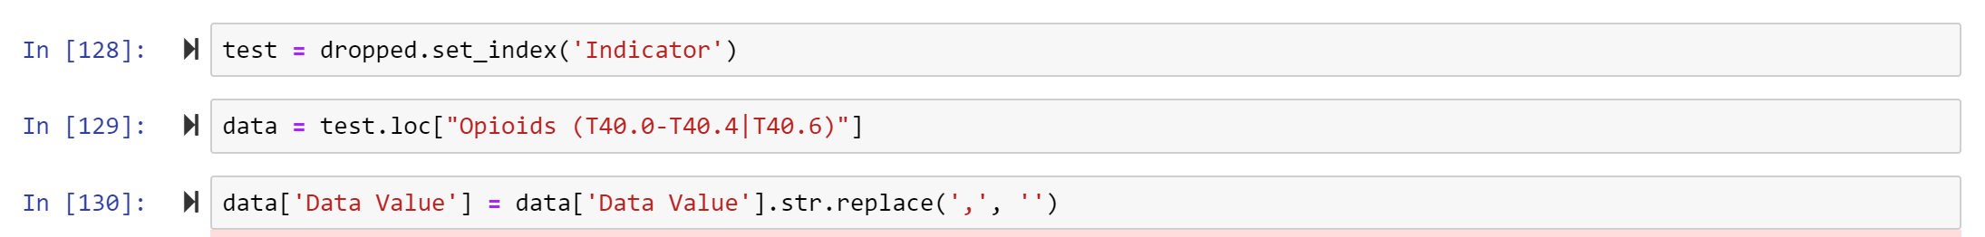

# 

# ERD DIAGRAM

The ERD diagram is a type of structural diagram for use in database design. This shows how we designed our database to study the opioid crisis.

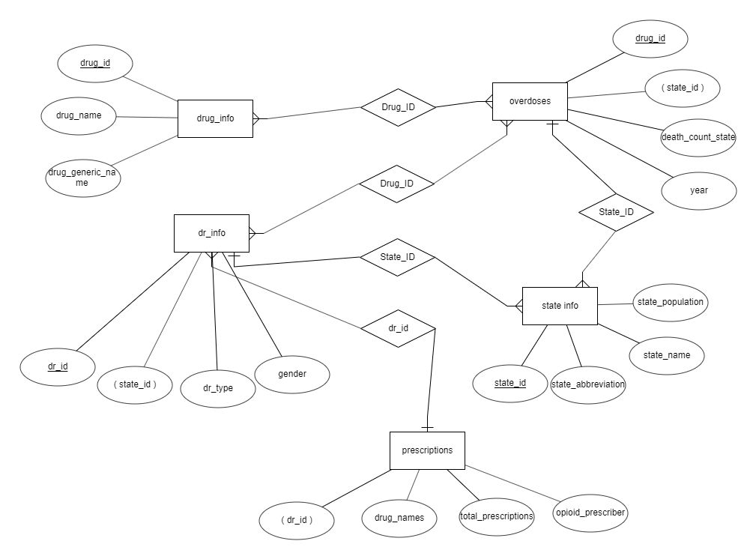

# TABLE SCHEMA

-- ETL table schema

--Opioid Table

CREATE TABLE opioids (

drug_id INT PRIMARY KEY,

drug_name VARCHAR(30),

generic_name VARCHAR (30)

);

-- State Table

CREATE TABLE states (

state_id INT PRIMARY KEY,

state_abbv VARCHAR(30),

state_name VARCHAR(30),

state_pop INT

);

-- Overdoses Table

CREATE TABLE overdoses (

state_id INT,

year INT,

deaths INT,

FOREIGN KEY (state_id) REFERENCES states(state_id)

);

-- Doctor Table

CREATE TABLE prescribers (

doctor_id INT PRIMARY KEY,

doctor_type VARCHAR (100),

state_id INT,

gender VARCHAR (1),

FOREIGN KEY (state_id) REFERENCES states(state_id)

);

-- Prescriptions Table

CREATE TABLE prescriptions (

doctor_id INT,

ACETAMINOPHEN_CODEINE INT,

DIPHENOXYLATE_ATROPINE INT,

FENTANYL INT,

HYDROCODONE_ACETAMINOPHEN INT,

HYDROMORPHONE_HCL INT,

METHADONE_HCL INT,

MORPHINE_SULFATE INT,

MORPHINE_SULFATE_ER INT,

OXYCODONE_ACETAMINOPHEN INT,

OXYCODONE_HCL INT,

OXYCONTIN INT,

TRAMADOL_HCL INT,

Total_Opioid_Prescriptions INT,

Opioid_Prescriber VARCHAR (3),

FOREIGN KEY (doctor_id) REFERENCES prescribers(doctor_id)

);

# QUERIES & RESULTS

Here are our queries and results:

1. **XXXX:**
2. **XXXX**
3. **XXXXX**
4. **XXXXX**
5. **XXXXX**